38.72: a) Power delivered = pIV.
b) 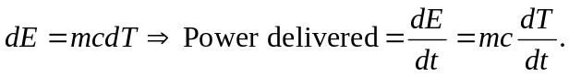
So 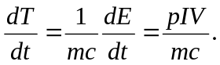
c) (a) Power
(b) 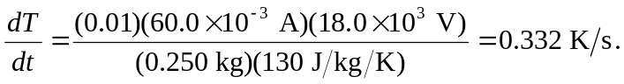
d) A high melting point and heat capacity—tungsten and copper, for example.

